 | worksheet  First Semester  Academic Year (2025/2026)  Singular and plural  Unit 3
Name : | Date: | Grade:1
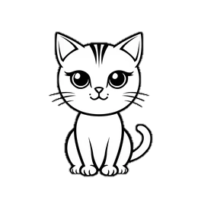 |  |  |  | 
cat | cats | apple | apples | flower | flowers
 |  |  |  | 
pen | pens | hat | hats | book | books
 |  |  |  | 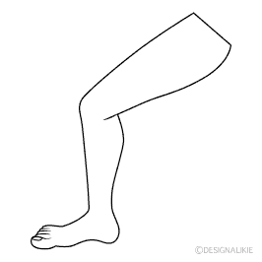
car | cars | pencil | pencils | legs | leg
Choose:
Write the plural form:
Dog
fan
bed
Frog
box

