 | Study sheet  Final exam  First Semester  Academic Year (2025/2026)
Name : | Date: | Grade:2
Q1- Choose:
hand
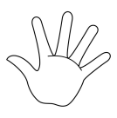 | 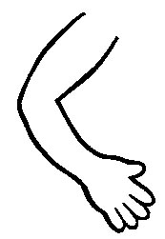
nose
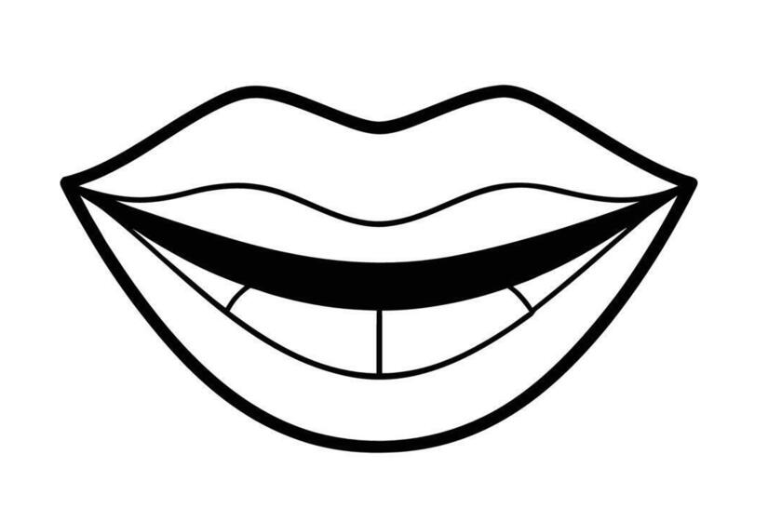 | 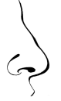
dad
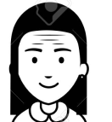 | 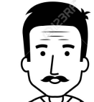

fingers
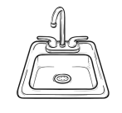
brother
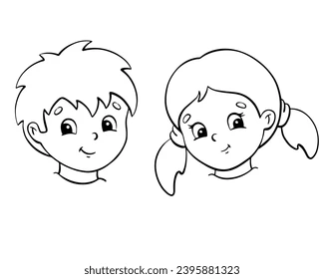
ear
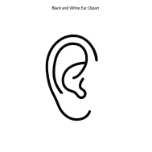 | 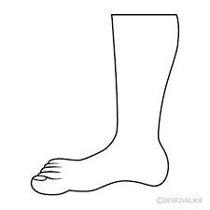

arm
Grandad
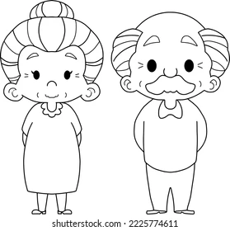
mum

Q2-Circle:
1-He……………………………….got 2 legs. | has | have
2-I……………………………….got 2 arms. | has | have
2-She……………………………….got 3 eyes. | hasn't | haven't
Q3-Circle:
1-I have got 1………………………………. | nose | noses
2- I have got 1………………………………. | face | faces
1- I have got 2………………………………. . | arm | arms

Q4-complete with (ee) or (ar)
1-……ms 2-f….t 5-f….m 7-bro…er
3-kn…..s 4-p….k 6-….umb 8- b……

Match:
Touch | Your legs
Stretch | Your hands
Move | Your feet
Clap | Your toes
Stamp | Your knees
bend | Your arms

Read and tick () or (×)
I've got ten fingers. | 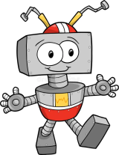
I've got four arms.
I've got three legs.
I've got two feet.

