 | worksheet  First Semester  Second exam  Academic Year (2025/2026)  Unit 2
Name : | Date: | Grade:2
Choose:
bag
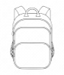 | 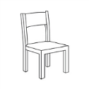
book
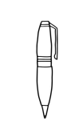 | 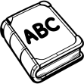
crayon
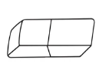 | 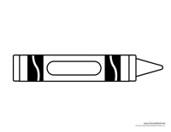

pencil
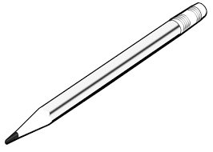 | 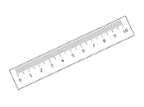
ruler
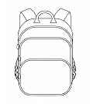
eraser

Look at the pictures and write the correct preposition of place to complete the sentences:
in / under / on:
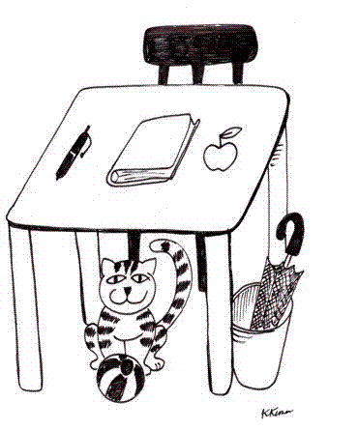
1- The book is ………………………………..………….the table.
2- The cat is ……………………………………………….the table.
3- The umbrella is …………..……………………….the bin.
4- The apple is……………………………………….…….the table.

Complete:
Remember:
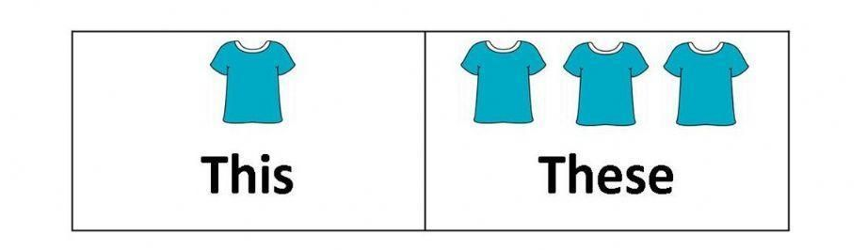
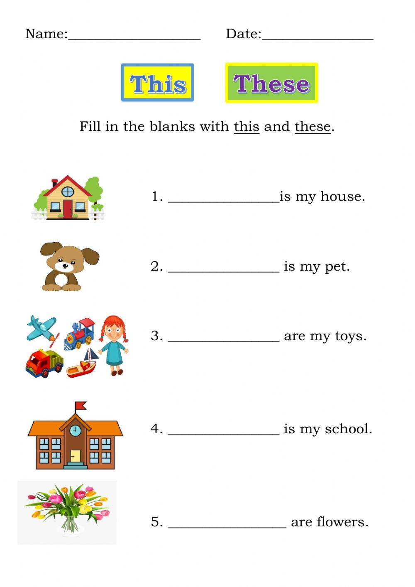

-complete with (sh) or (ch)
1-……ick 2- ….eese
3- …..elf 4- ….op

