 | Study sheet  First Semester  Academic Year (2025/2026)
Name : | Date: | Grade:1
Q1- Choose:
bag
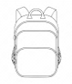 | 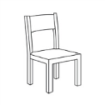
crayon
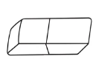 | 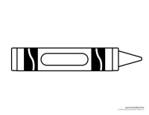
book
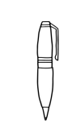 | 

pencil
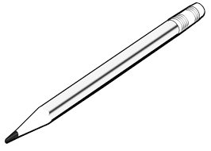 | 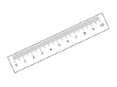
eraser
ruler
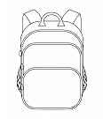

Q2- Color:
Red | blue | green | yellow

Q3- look and write (I have got / I haven't got):
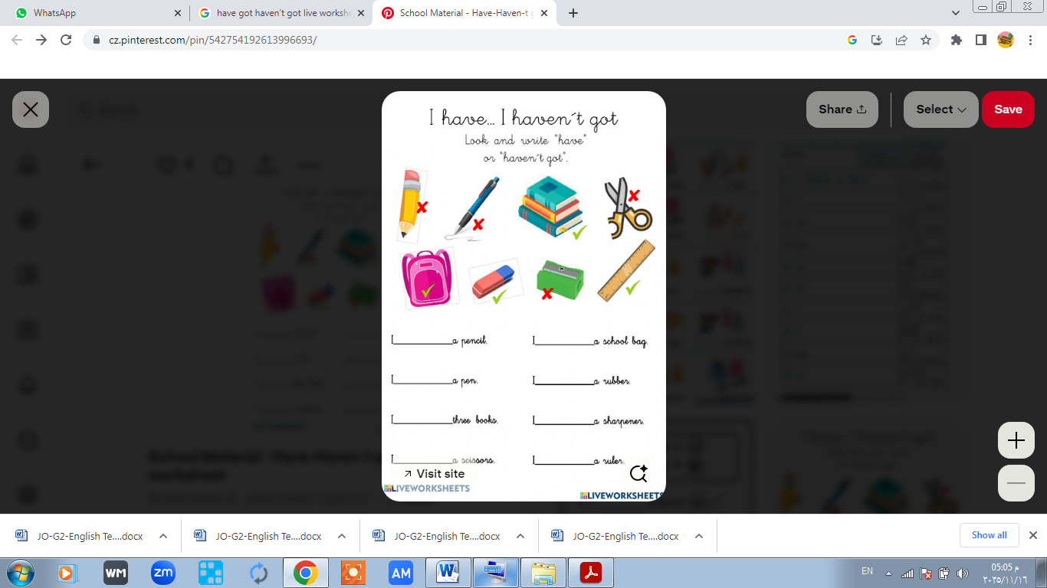
I ------------------------a pencil | I ------------------------ a ruler
I ------------------------a bag | I ------------------------ a pen
I ------------------------a sharpener | I ------------------------ an eraser
I ------------------------ scissors | I ------------------------books

Q4-Write the capital letter:
b

p

r

e
Write the missing letter (e-r-p-b)
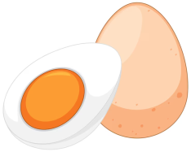 | 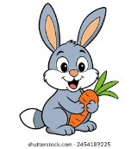 |  |  |  | 
..gg | ….abbit | …en | …lbow | …all | ..ink

