امتحان نھایة الفصل الدراسي الأول 2024/2025
مادة / اللغة الإنجلیزیة
الصف الثالث

ملاحظة: اجب عن كل الأسئلة والتي عددھا( 6 )وعدد الصفحات (2 )
Note: Answer all questions which are ( 6 ) and the pages are ( 2 )
Q1: Circle the correct answer: ( 6 points )
- I want to be a …………………………. ( doctor / school )
- Sami ………………………………… a book. ( reads / read )
- She ………………………………… TV. ( don’t watch / doesn’t watch)
- We …………………………….. wearing dresses. ( is / are )
- I ………………………… with my friends. ( play / plays )
- I want to be …………………………………… artist. ( a / an )
Q2: Write the correct word under each picture: ( 8 points )
do karate | chef | boat | motorbike
teacher | roller skate | pilot | play video games
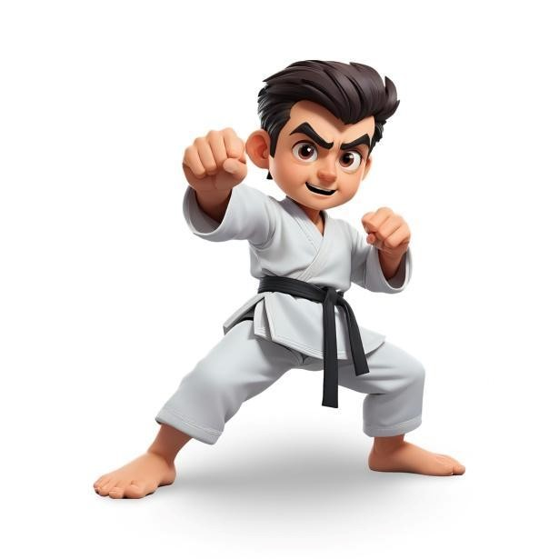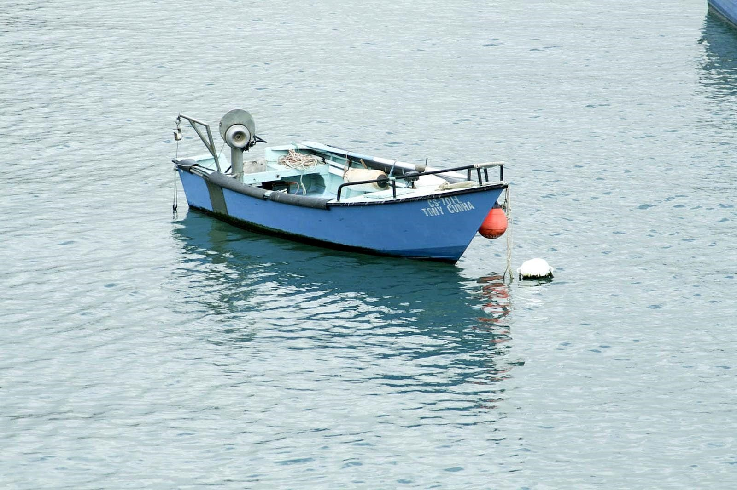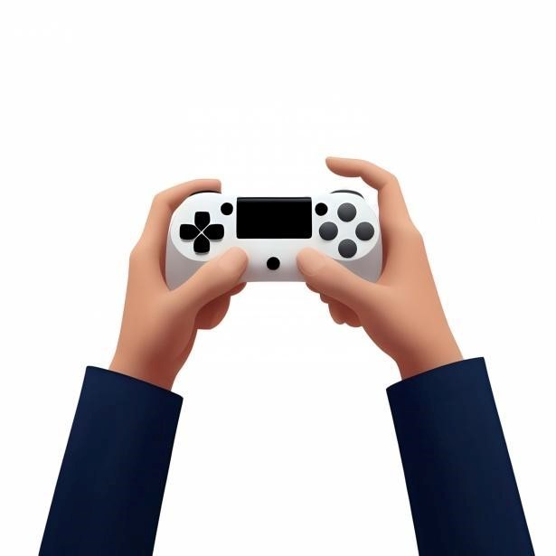
_______________ ______________ ______________ _______________
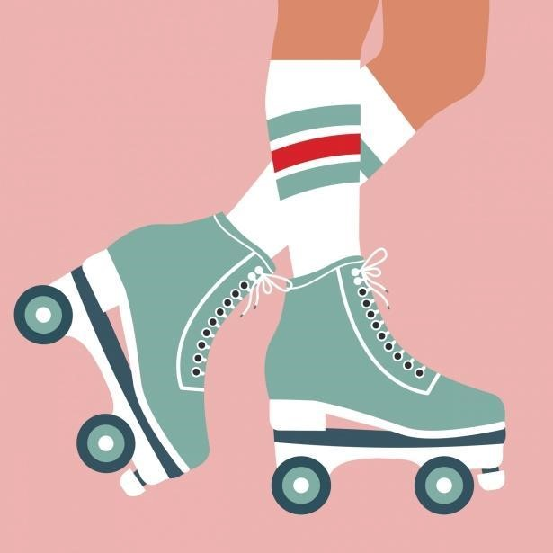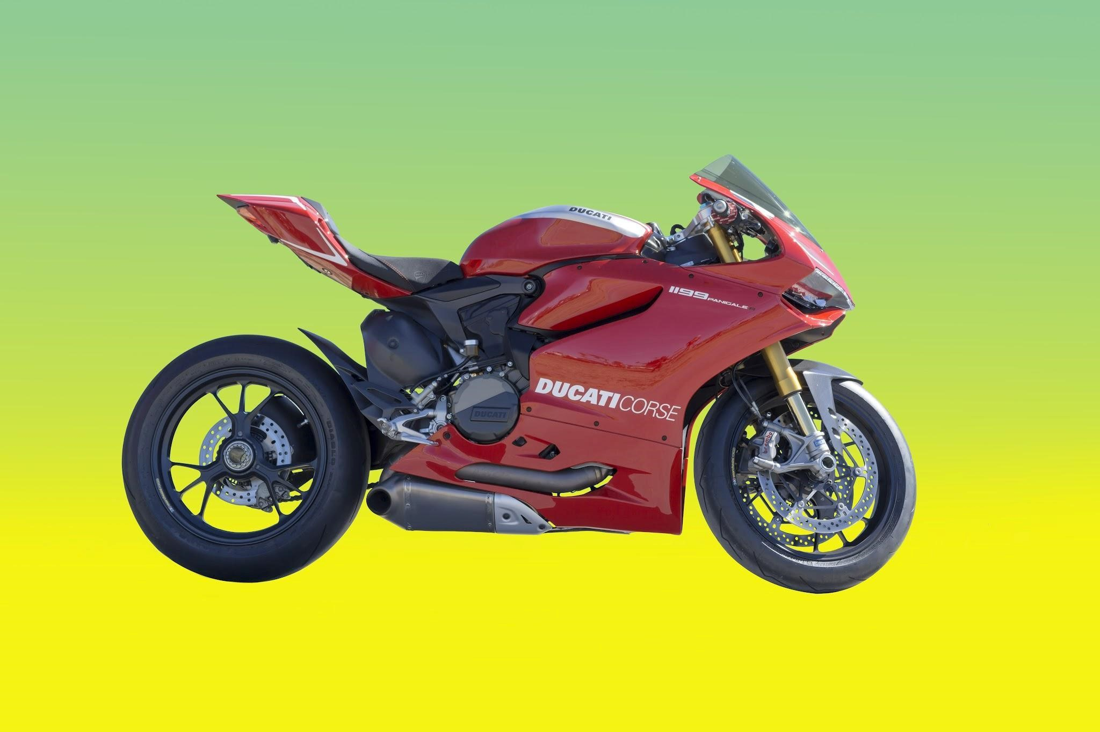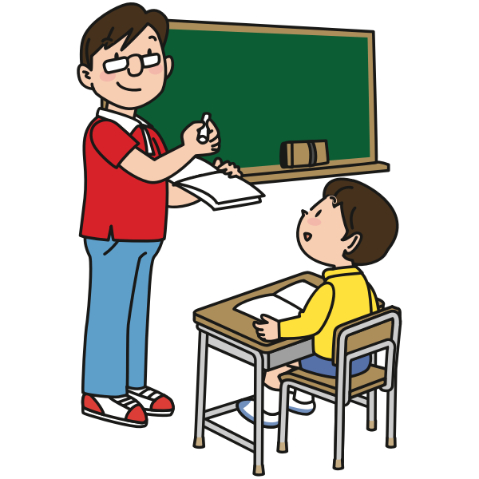
________________ ______________ ________________ ________________
Q3: Order the days of the week: ( 1 point )
Tuesday / Monday / Sunday

……………………………………………………………………………………………………………

Q4: Read the following text and answer the questions that follow: (5ps)
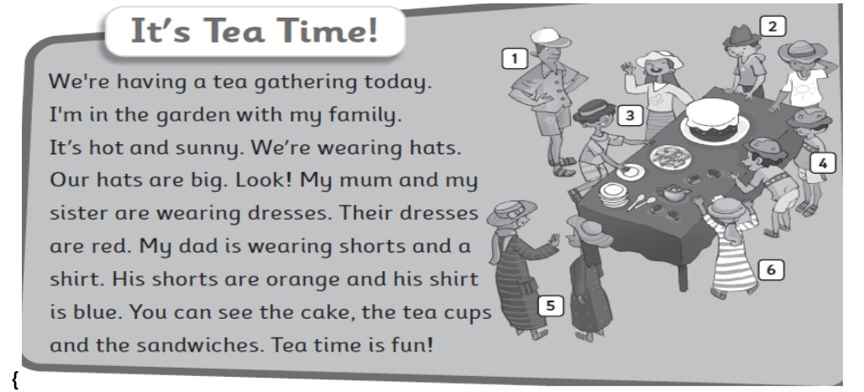
- They are wearing dresses. ( Yes / No )
- Dad is wearing shorts. ( Yes / No ) 3. Their dresses are red. ( Yes / No)
- Find a color …………………………………………………………….
- Find a drink ………………………………………………………………
Q5: Put the correct word in each blank. ( 3 points )
morning | night | afternoon

- We have breakfast in the ______________________.
- We go to bed at ________________________________.
- We have lunch in the ___________________________.

Q6: Listen and match. ( 2 points )
pl | wh | br | sw

- ___ ___ ale
- ___ ___eet
- ___ ___ ead
- ___ ___ ane

Teacher
Feryal Abu Hwaij^^

